The Dormann
Calendar of Events for April 2021

Sunday | Monday | Tuesday | Wednesday | Thursday | Friday | Saturday
 |  |  |  | 1 | 2 | 3
4 | 5 | 6 | 7 | 8 | 9 | 10
11  April is… | 12  Poetry Month | 13  Lawn & Garden Month | 14 | 15 | 16  Check out:  Discovery Kids  Theme: Trees  on Facebook  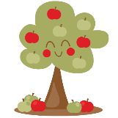 | 17
18  Story Walk  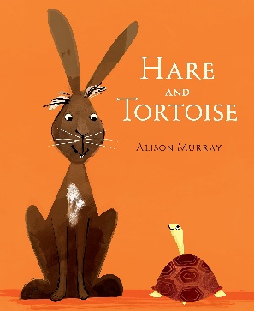  Come and walk our grounds and read a story!  (4/19 - 4/30) | 19  11:00am – 5:00pm  Stop in all week to make a poetry button (3 per day, per person). | 20  You can also make some blackout poetry. Open to all ages.  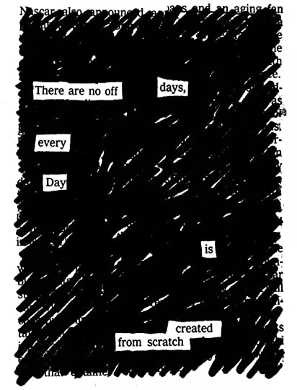 | 21  White Spruce Tree Giveaway  Sign-up Required. | 22  Earth Day  3:00pm – 5:00pm  Fairy House Build  We will only be using found objects. You can’t pick anything. We will be placing the houses around the library grounds.  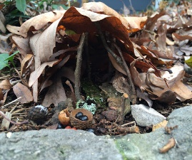 | 23  Check out:  Discovery Kids  Theme: Nature  on Facebook | 24
25 | 26  6:00pm – 7:30pm (Zoom)  Oryx and Crake by Margaret Atwood | 27  11:00am – 5:00pm  Stop in all week and make a Yarn Stick or Weaving. Open to all ages. | 28 | 29  Arbor Day  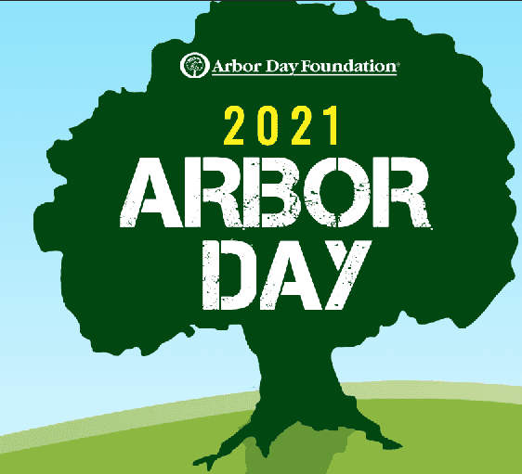 | 30 | 1
101 West Morris Street, Bath, NY 14810 / Phone: (607) 776-4613 / Web site: www.dormannlibrary.org

